

**ADAPTIVE TEST SYSTEM**

**NACHIKETH DORAISWAMY** (A0215523N)

**LAKSHMI SUBRAMANIAN** (A0215255L)

**YALAVARTI DHARMA TEJA** (A0215457A)

TABLE OF CONTENTS

REQUIREMENTS

System Overview

Recommended Browsers

Tech stack

User Interface

Installation Guide

Back-end

Frond-end

USER GUIDE

TEST CASES: SAMPLE INPUT AND SAMPLE OUTPUT

TEST CASE : STUDENT

TEST CASE : TEACHER

REQUIREMENTS

SYSTEM OVERVIEW

The system architecture is mainly composed of 3 components:

* MR business rule set
* GA optimizer algorithm
* Intelligent QnA solver

MR business rules are a set of directives that are used to govern the level in the difficulty of questions per topic (easy/ medium / hard) based on the previous performance of the test taker in the same topics.

GA optimizer algorithm uses the previous test scores in individual topics as a benchmark to decide the number of questions for the subsequent test in that particular topic. The GA caters to individual students and delivers an efficient and optimized set of questions in an adaptive manner in order to test the preparedness of the test taker.

Intelligent QnA solver is used for the purpose of self-learning and reasoning. With the help of this tool the future test taker has the access to the study material and at the same time he/she will have the facility to search for a solution in a question answer format.

RECOMMENDED BROWSERS

Adaptive Test System supports the following browsers:

* Internet Explorer 10 and above
* Firefox 52 ESR and 53 and above
* Google Chrome version 59 and above
* Safari version and above

TECHSTACK

Back-end

* Python
* Mongo DB

Front-end

* HTML/CSS/JAVASCRIPT

USER INTERFACE

* Our interface consists of an interface for a student and a teacher.
* The teacher has facility to evaluate and update scores of the test taker(student).
* The student has the ability to take a new mock test to assess his/her skills by clicking on the button that generates a new set of questions based on the previous performance. He also has the facility to view his previous test scores along with the solutions where he can assess as to where he was wrong or right.

INSTALLATION GUIDE

Back-end

* Clone the repository <https://github.com/Doraiswamy/Adaptive-Test.git> into a separate directory.
* Choose the editor of your choice. For example, PyCharm, Spyder etc.
* Navigate to the ‘backend’ folder inside the ‘SystemCode’ folder.
* An optional step is that you can set up a virtual environment to install your dependencies inside the project folder. This helps in avoiding mixing up of different environments. Please follow the link given here: https://uoa-eresearch.github.io/eresearch-cookbook/recipe/2014/11/26/python-virtual-env/
* Install all the dependencies for the project with the help of the command ‘pip install -r requirements.txt’.
* Run the server with the help of the command ‘python manage.py runserver 0.0.0.0:8000’.
* Navigate to the browser of your choice and in the search bar paste the following URL: http://localhost:8000 to check whether the server is running or not.

** Note: It is assumed that python 3.0 or above is already installed in your system. If not please install the latest python version from the link given below:

<https://www.python.org/downloads/>

Front-end

Open the browser of your choice. In this case, we are using Mozilla Firefox. Make sure that CORS addon is installed in your browser and is enabled.

**What is CORS and why we need the corresponding addon enabled :**

CORS stands for ‘Cross Origin Resource Sharing’. If your WebDAV server (WebDAV stands for Web Distributed Authoring and Versioning, which is an extension to HTTP that lets clients edit remote content on the web) is located on a different domain, on a different port or using different protocol (HTTP / HTTPS) such requests are considered to be cross-origin requests and by default are prohibited by most browsers.

In order for the browser to respond to the cross-origin requests we install this addon and enable the same.

For Chrome, the corresponding addon/extension is named as ‘Cross Domain - CORS’.

For Firefox, the corresponding addon is named as ‘CORS Everywhere’. The following is the screenshot for reference :

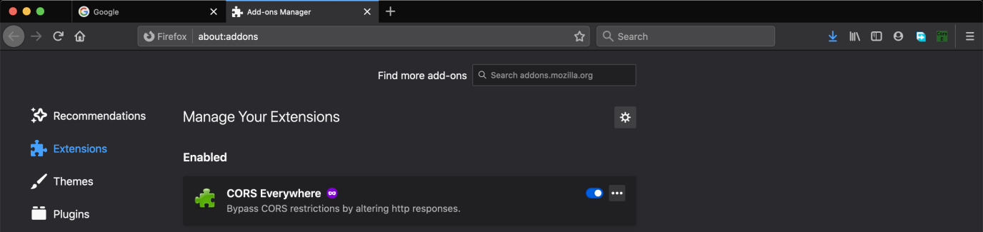

Once the addon is installed and enabled, open the ‘login.html’ page which is present under the folder Frontend > student adaptive test.

Once the login page is open, please follow the user guide below that showcases the various options available along with corresponding screenshots for both the student and teacher.

USER GUIDE

TEST CASE : STUDENT

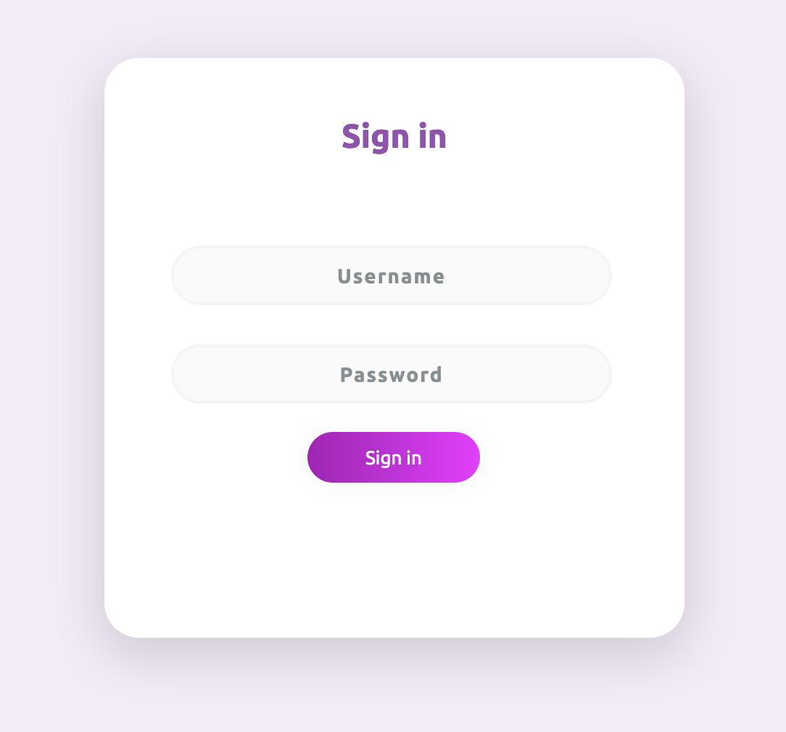

Once on the login page, enter the student credentials to get into the corresponding student page.

In our case the credentials are :

Username : KVTE53627

Password : mahesh

Click on ‘Sign in’.

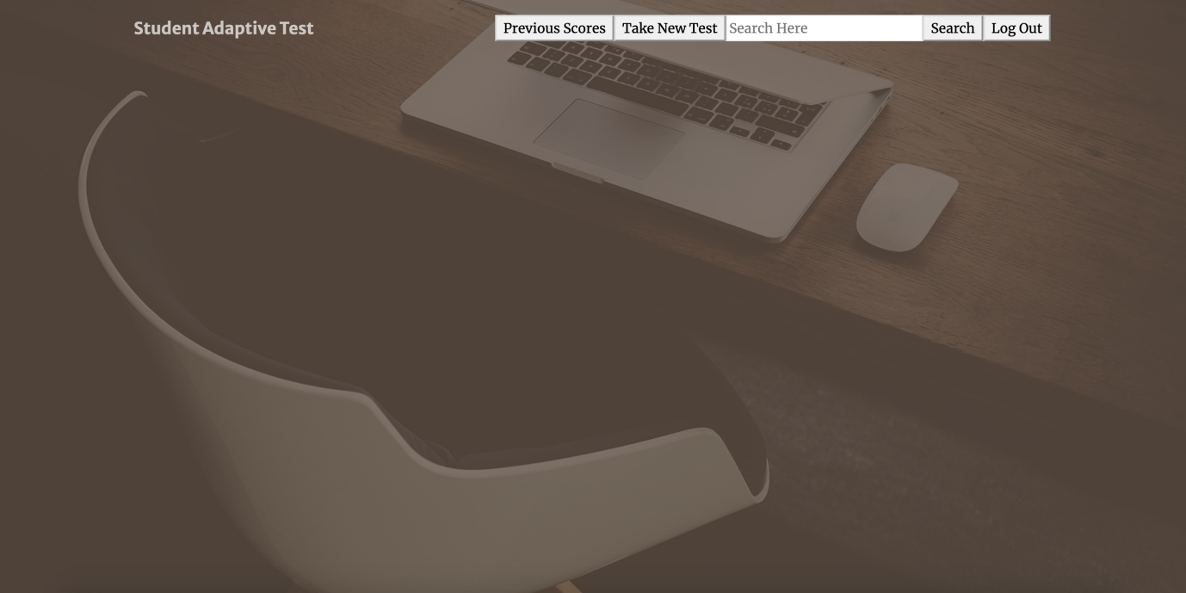

The above screenshot represents the student homepage. The student can click on ‘Take New Test’ button to take a new assessment based on his previous performance/score.

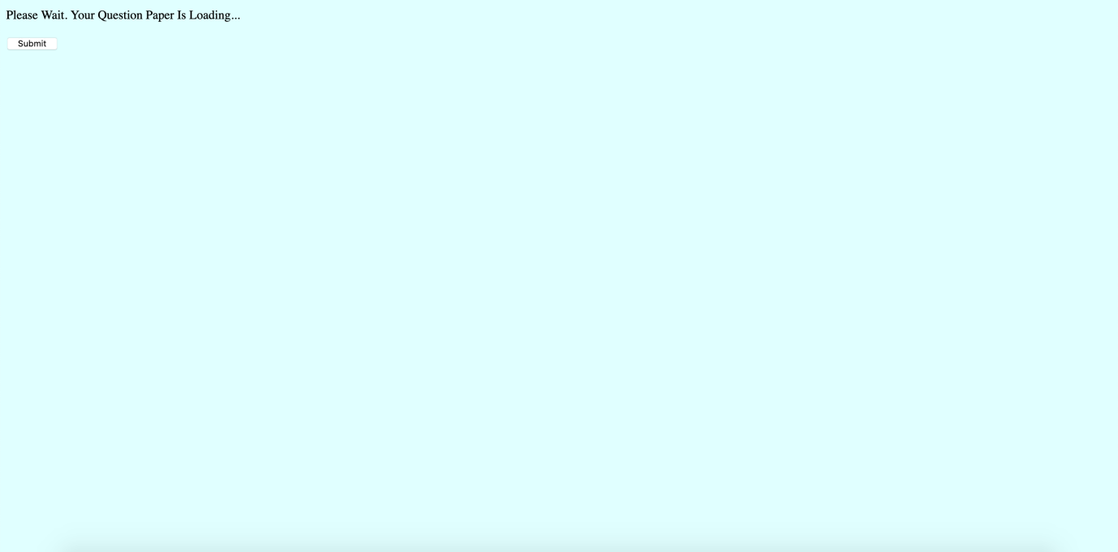



The above screenshots show the assessment page being loaded and once the page is loaded, the student can fill in the corresponding answers in the text box provided after each question.

Once the student completes the assessment, he/she can click on the ‘Submit’ button and the corresponding questions and answers would be uploaded into the database and the student would see a response stating ‘test details uploaded successfully’.

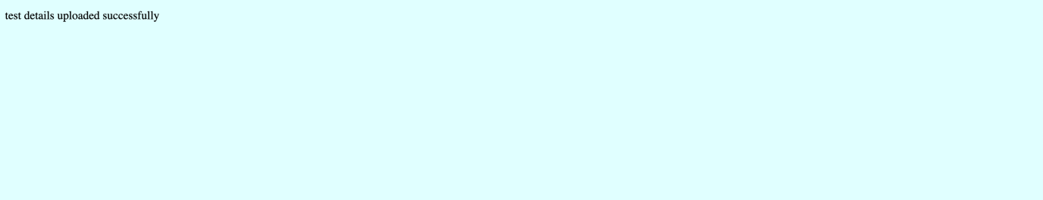

Now the assessment details are uploaded successfully to the database and the next step is for the teacher to evaluate these answers and provide a score. Evaluation from the teacher’s end is shown under ‘TEST CASE : TEACHER’ in the next section. Once the teacher completes evaluation and uploads student score, the student can then login back to his account and click on ‘Previous Scores’ to view the score that they received in the corresponding assessment.



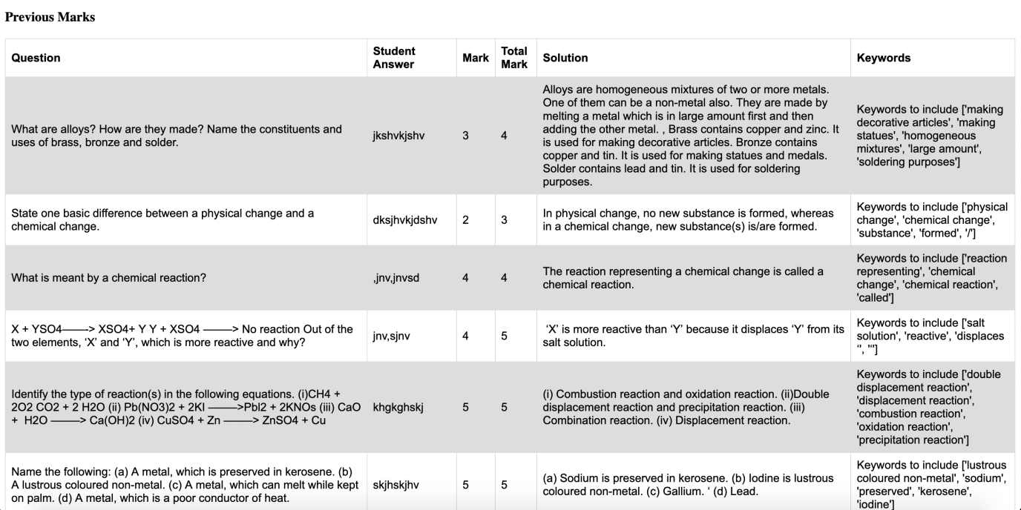

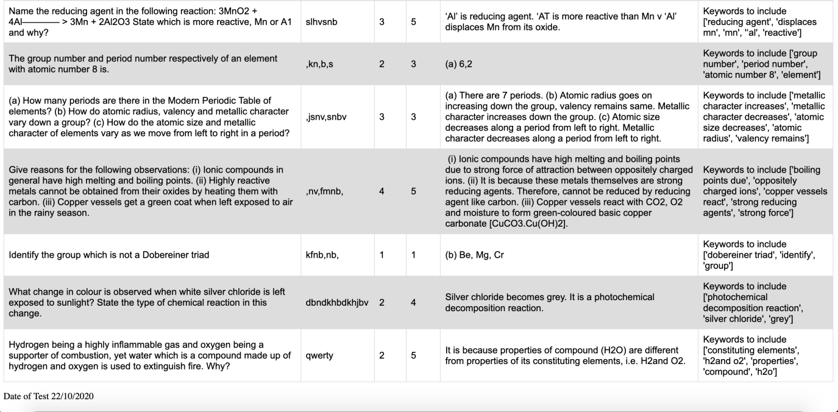

The ‘Previous Scores’ page would reflect the Question, Student Answer, Mark (given by teacher), Total Mark (for that question), Solution, Keywords that could have been included in the answer and Date of Test.

The student, based on the score awarded, can come back to their homepage and use the search box functionality to learn more on the concepts where they scored less in the assessment.

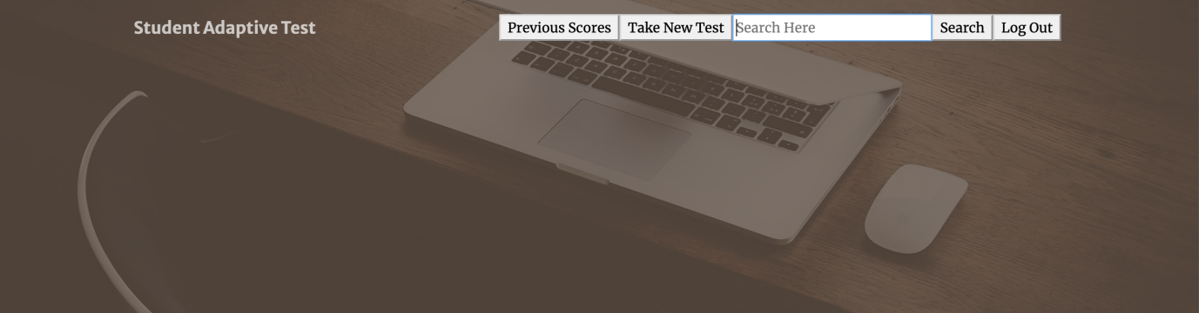

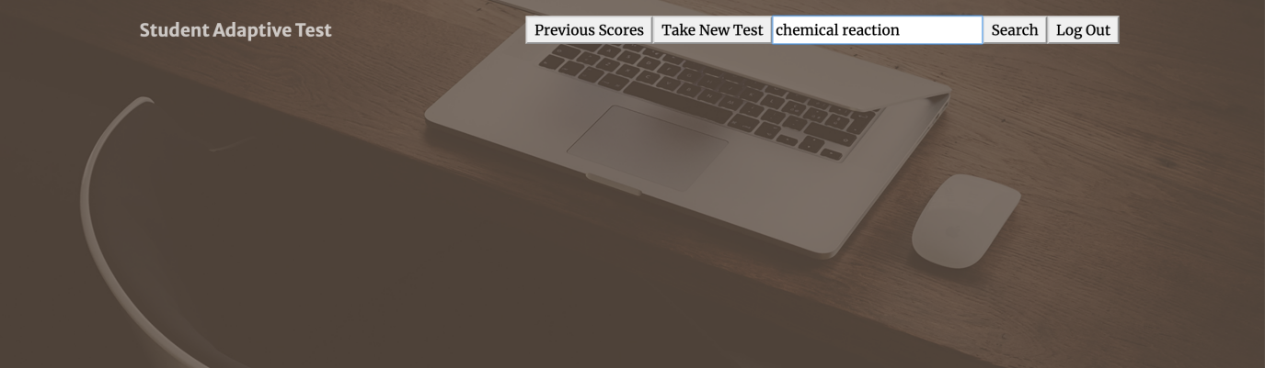



This way, the student can learn more on the concepts that they are weak in and try to score well in the next assessment.

TEST CASE : TEACHER

Once the student completes the assessment, the teacher would then login to their account using the ‘login.html’ page present under the folder Frontend > student adaptive test.

Once on the login page, enter the teacher credentials to get into the corresponding teacher page.

In our case the credentials are :

Username : KV9553870

Password : nachiketh

Click on ‘Sign in’.



The above screenshot represents the teacher’s homepage. The teacher can click on ‘Update Student Scores’ button to be able to evaluate the student’s previous assessment.

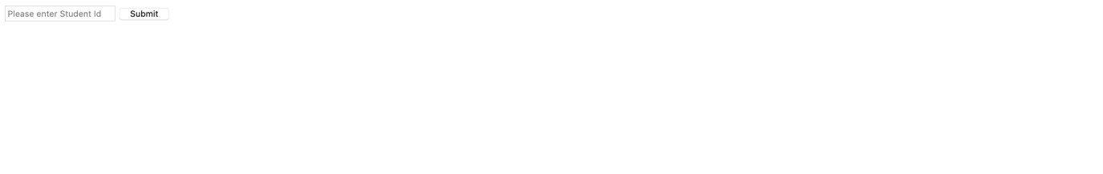

The teacher would then be asked to input the student id for which they would like to do the evaluation. Here, the student id can be entered as : KVTE53627. Once the corresponding student id is entered and clicked on Submit button, the page would load student’s answers for the respective questions and the teacher can evaluate the same by awarding appropriate marks.

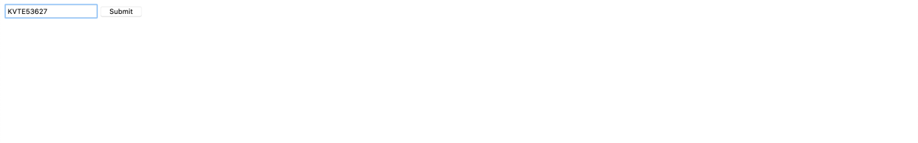

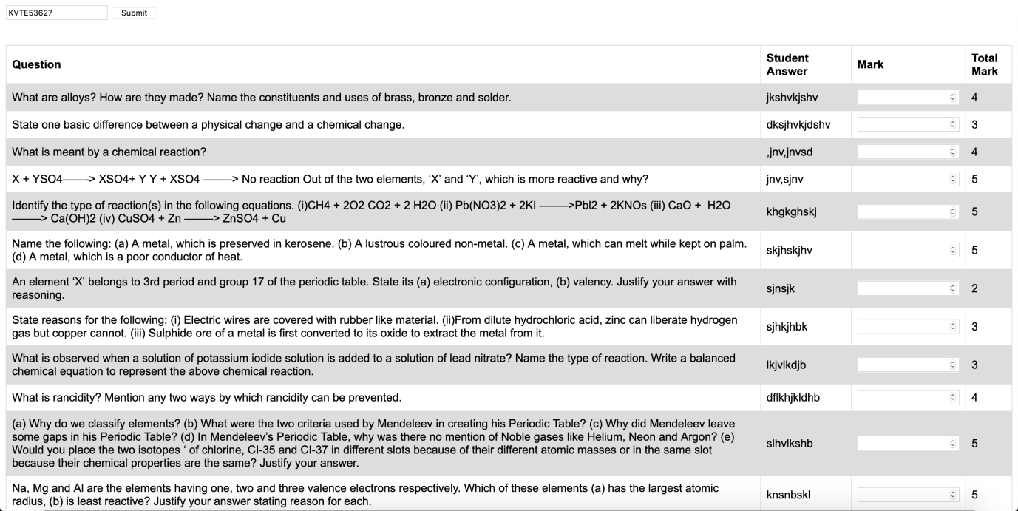

Once the teacher awards appropriate marks, they can click on ‘Update Marks’ button to upload the corresponding marks into the database.

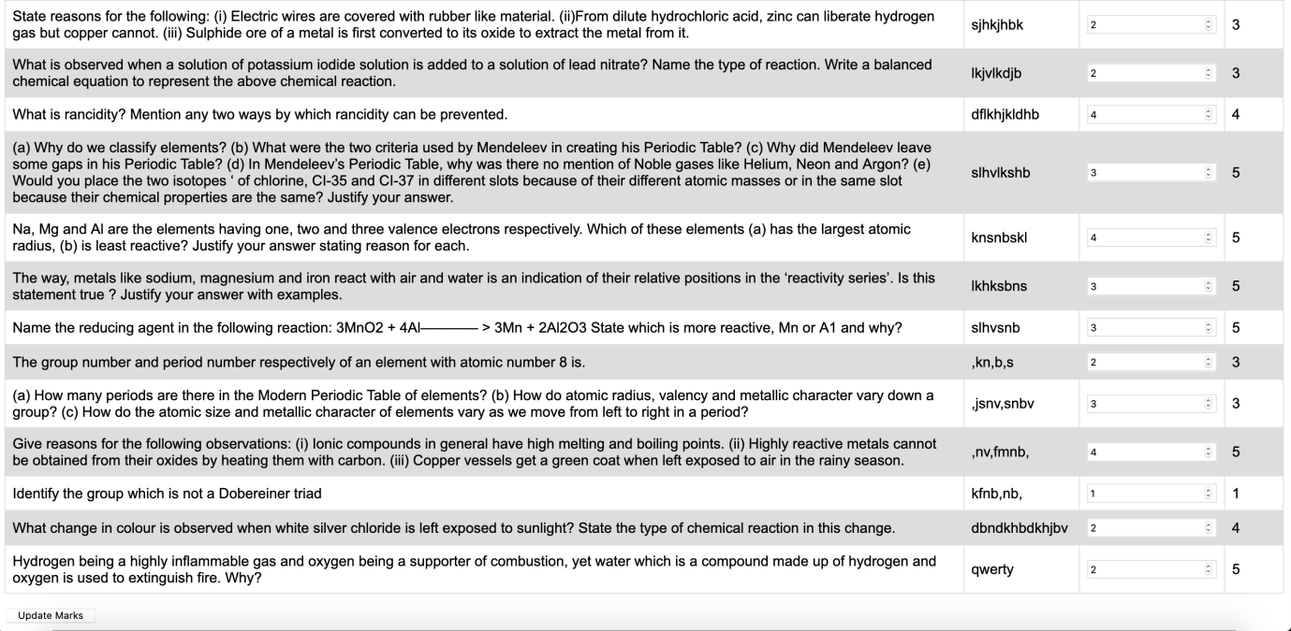

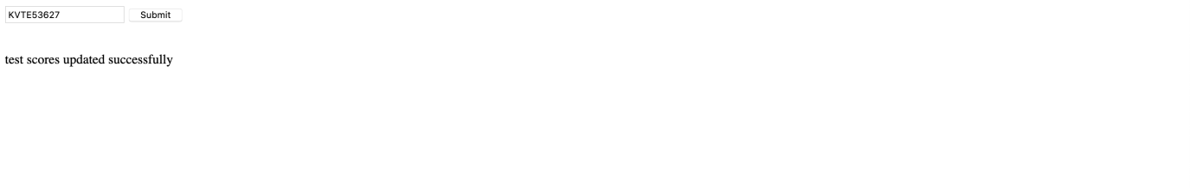

The student can now login to their account and click on ‘Previous Scores’ to be able to view the score awarded by the teacher in the corresponding assessment.